**Student Name: Shinde Smita Shahaji UID: 20BCS4643**

**Branch: CSE-(IOT) Section/Group:IOT- Group B**

**Subject Name: Digital Electronics Date of Performance:4/1/2021**

**Aim**

Design a pulse width modulated signals generator using 555.

**Task to be done**

*(Objective of the task to be explained)*

* Here we are using a 555 timer IC for generating PWM. 555 timer IC is a very useful and general-purpose IC which can be used in many applications.
* Here we have controlled the output frequency of the PWM signal by selecting resistor RV1 and capacitor C1.
* We have used a variable resistor in place of fixed resistor for changing duty cycle of the output signal.
* Capacitor Charging through D1 diode and Discharge through D2 diode will generates PWM signal at 555 timer's output pin.
* Below formula is used for deriving the frequency of the PWM signal:

F = 0.693*RV1*C1

Ton= 0.693*(RA+RB)*C1

Toff= ).693*(RB)*C1

**Requirements**

*(Hardware and software requirements)*

# Software –

Tinker cad.

# Hardware –

|  |  |  |
| --- | --- | --- |
| Sr.no | Apparatus | Quantity |
| 1. | 555 timer IC | 1 |
| 2. | 10K potentiometer | 1 |
| 3. | 1kohm resistor | 3 |
| 4. | 0.1uF capacitor | 2 |
| 5. | 9v Battery | 1 |
| 6. | Connecting wires, jumper wires | 26 |
| 7. | Breadboard | 1 |
| 8. | Battery connector | 1 |

**Circuit diagram/ Block diagram**

*(Insert circuit diagram here)*

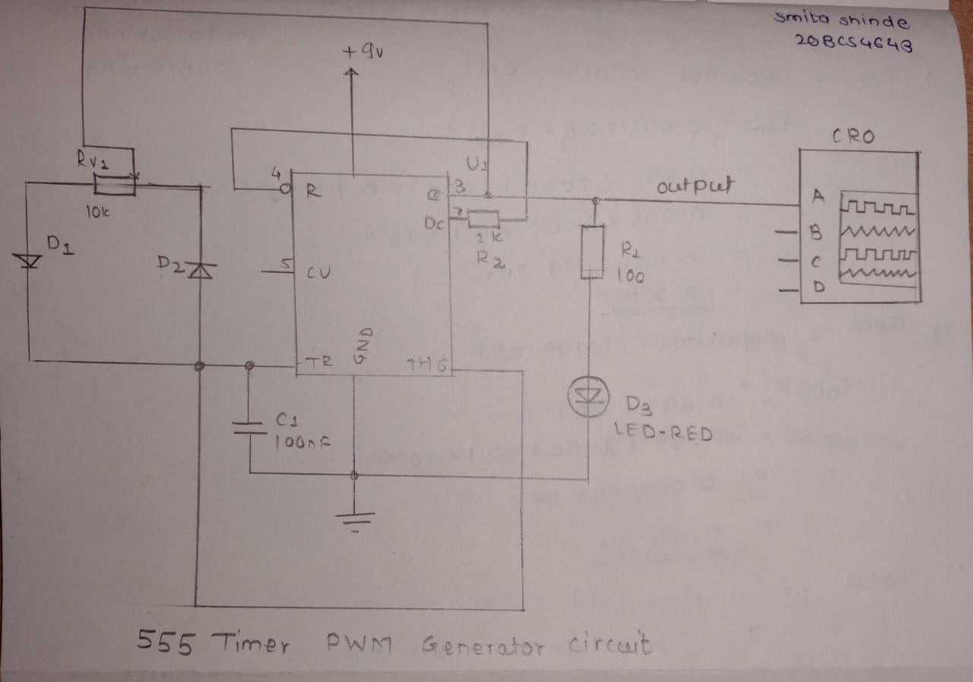

**Duty cycle of the PWM**

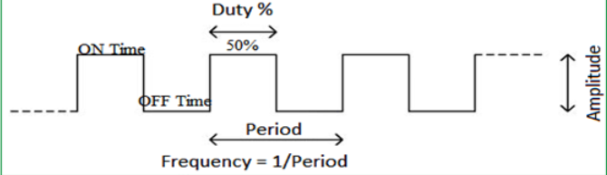

Circuit diagram on thinker-cad

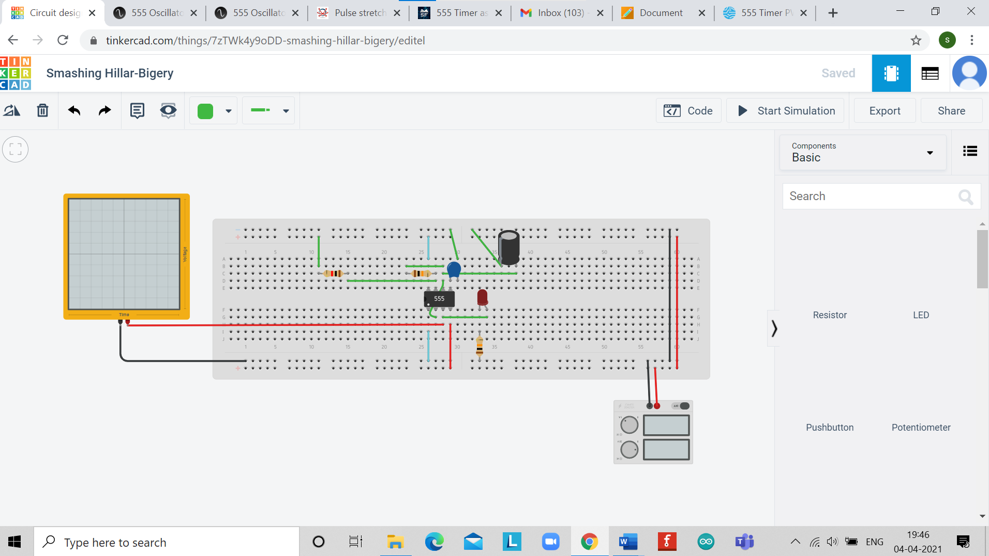

**Simulation Results:**

*(Insert simulation results )*

* When I took R1 is equal to 5K-ohm and R2 took as 5k-ohm and capacitor is 10 micro farad and polarized capacitor is 10 nF then we got output on oscilloscope Ton as more than Toff.

#### **Simulating PWM generation using 555 Timer IC:**

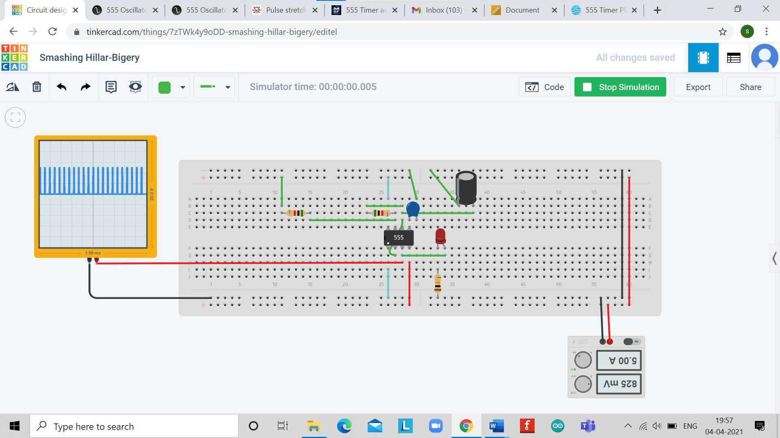

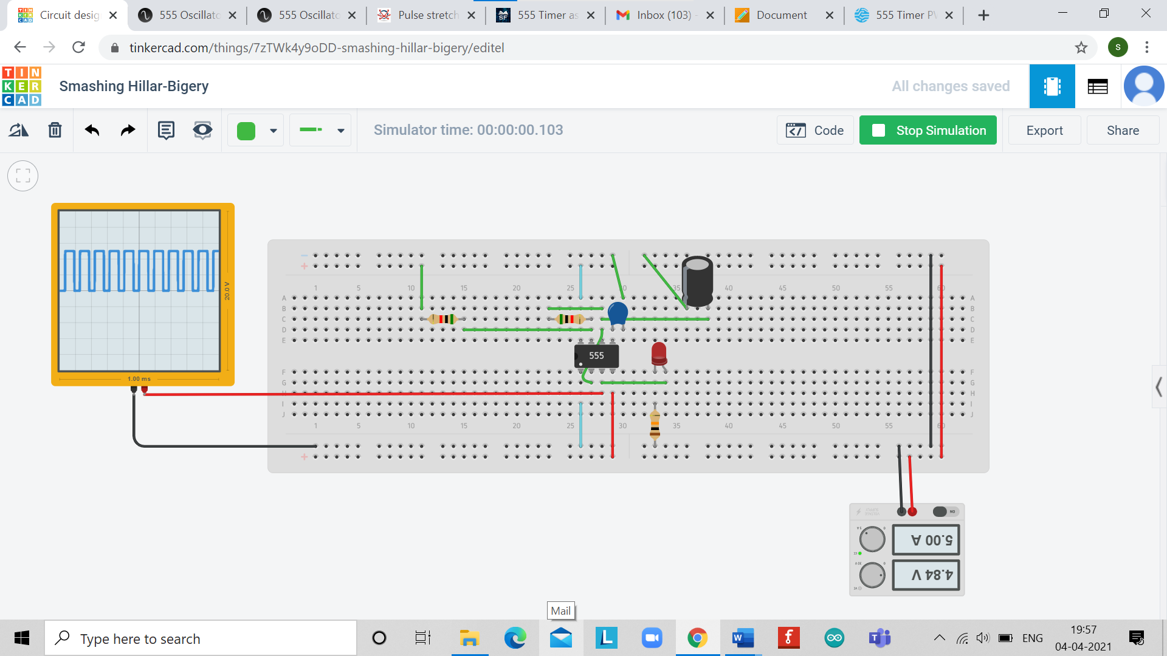

**Concept used**

From above the circuit diagram of 555 timer is Astable mode, it is clear that the capacitor is charging through R1 and R2 while it is discharging only through R2

Hence, if we replace R2 with a potentiometer, we can control the charging and discharging tines of the capacitor and essentially the duty cycle of the PWM signal.

I chose R1 as 5K-ohm, R2 as a 5K-ohm potentiometer and C as 10nF capacitor.

* I used the formula to predict my output is correct or not.

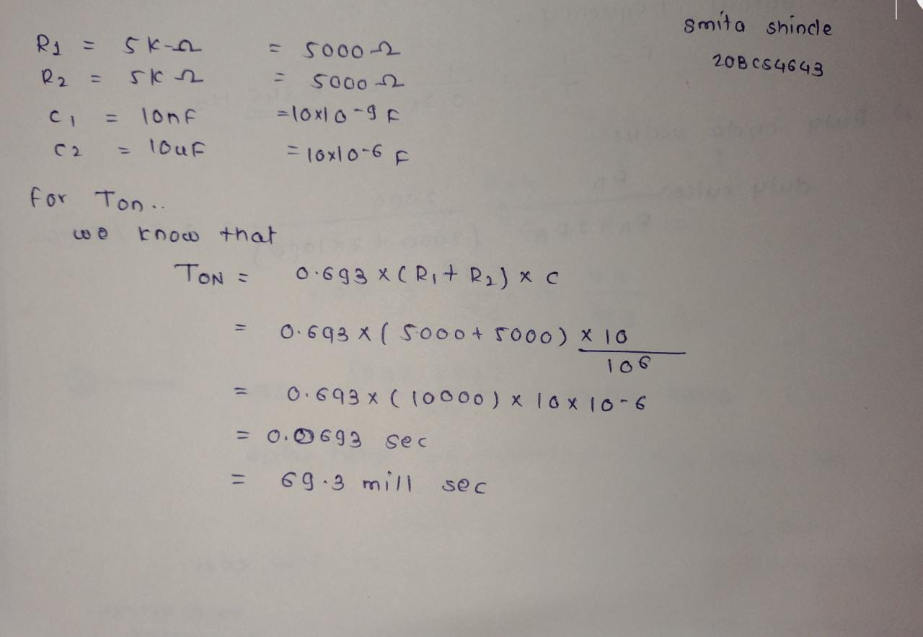

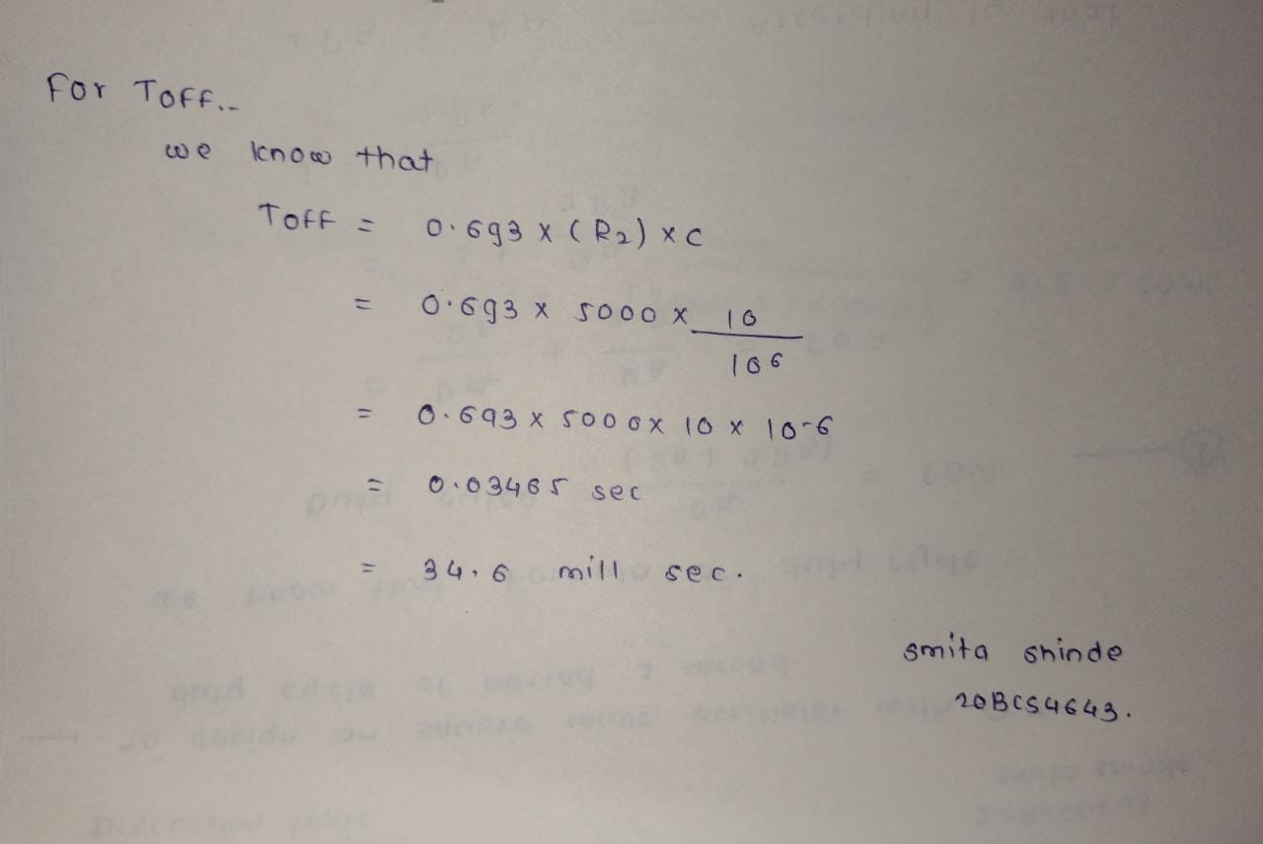

**Learning/ observation**

*(Observations made during the experiment and learnings for future reference)*

* PWM (Pulse Width Modulation) is an important feature of today’s every microcontroller due to its requirement for controlling many devices in every field of Electronics almost.
* PWM is widely used for motor controlling, lighting, controlling.
* Sometime we do not use microcontroller in our applications and if we need to generate PWM without microcontroller.
* we prefer some general-purpose ICs like op-amp, timers, pulse generators

**Troubleshooting**

*(Problems encountered and how did you solved those)*

The problem with it is that at the very beginning when it changes the duty cycle between about 1-3%, the PWM output goes haywire . At 0% its ok, at 4% to 96% it works fine and is stable, at 97-100% it goes crazy again.

The PWM square wave output from Pin 1 is stable; however I have noticed that at the problem points in the potentiometer travel (1-3% and 97-100%) it grows the smallest margin wider (time) until you cross past these problem spots.  
  
The diode D3 on the output helped clean the signal, and so did a capacitor, after that I fixed a problem.